# Introduction to Lambda Expressions in Java

## Introduction

In this tutorial, we will discuss

1. **Lambda expressions**,
2. their syntax, and
3. their usage.

This session focuses on the **theory** behind Lambdas in Java.

## What is a Lambda Expression?

- A **Lambda expression** is equivalent to **a function **without a name**\*\*.

- That is why It is also known as an \*\***anonymous function**\*\* in Java.

- Like a regular method, a lambda has:

- Method parameters

- Method body

- Return type

- Unlike regular methods, a **Lambda is not tied to any class**.

- It can be \*\***assigned to a variable**\*\* and **passed** like any other variable in Java.

## Lambda Expression Syntax

### **Structure of a Lambda Expression:**  
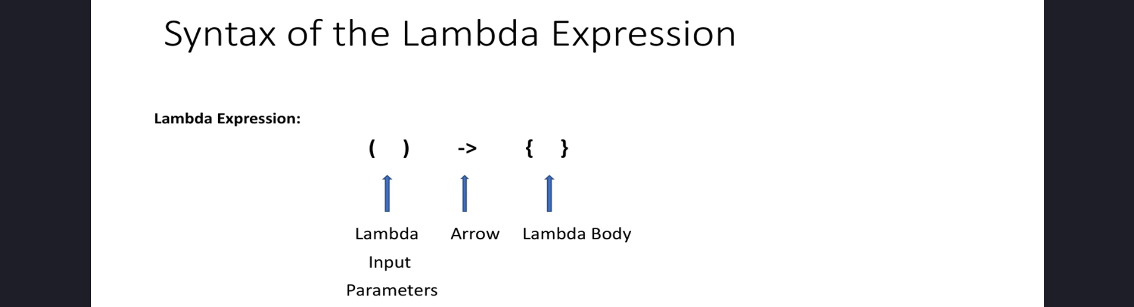

- **Parentheses** `( )` are used to pass input parameters.

- **Arrow operator** `->` separates input parameters from the method body.

- **Curly braces** `{ }` contain the method body, which defines the operation.

Example of a Lambda Expression:

(parameters) -> { method body }

## Usages of Lambda Expressions

### **Implementing **Functional Interfaces**\*\*

- The main purpose of Lambda expressions is to implement **Functional Interfaces**.

- Functional Interfaces are also called \*\***SAM (Single Abstract Method) Interfaces**\*\*.

- A **Functional Interface** is an interface that contains only **\*\*one** abstract method**.

- These interfaces are annotated with **\*\*@FunctionalInterface**.**

### **Examples of Functional Interfaces Before Java 8**

Some existing functional interfaces before Java 8 include:  


- **Runnable** (used for defining tasks in threads)

- **Comparator** (used for sorting collections)

## Next Steps

- In the next tutorial, we will implement **Comparator** and **Runnable** interfaces using Lambda expressions.

- We will also explore various use cases and benefits of Lambdas in real-world applications.

## Conclusion

- Lambda expressions provide a concise way to write \*\***anonymous functions**\*\* in Java.

- They are primarily used for \*\***implementing functional interfaces**\*\*.

- Java 8 introduced many built-in functional interfaces that can be used with Lambdas.

- Understanding Lambda expressions is essential for writing **modern Java code** efficiently.

### **End of the Tutorial**

Thank you for watching!